IWP Lab 7
Advait Deochakke
20BCE1143

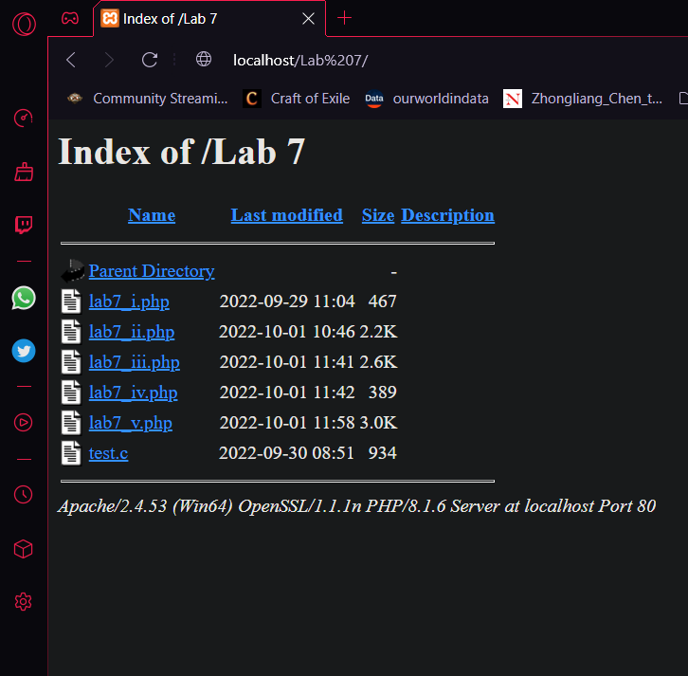





Code ->

<html>
<head>
<title>20BCE1143 - Ex 7</title>
</head>
<body>
<?php
echo "For loan of ₹10,000 <br>For interest of 10%p/m <br>Yearly payment is - ";
$principal = 10000;
$interest = 0.1;
$amount = 0 + $principal;
for($i = 0; $i < 12; $i++)
{
$amount = $amount + $interest * $principal;
}
echo "₹$amount<br>";
?>
</body>
</html>


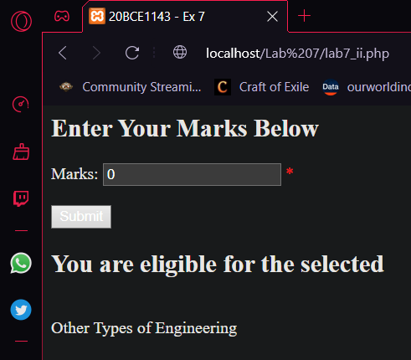

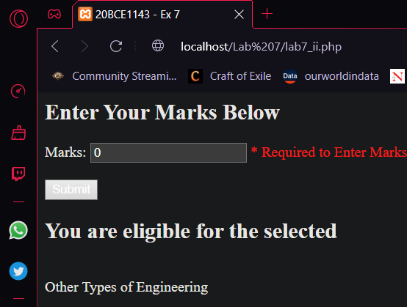

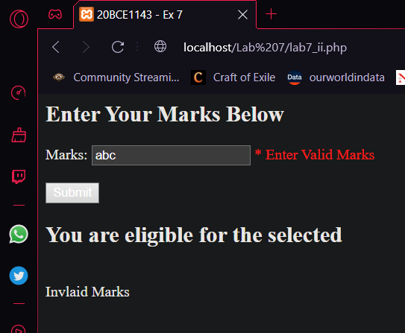

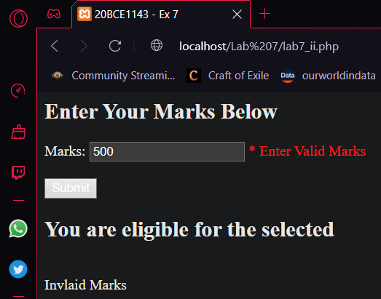

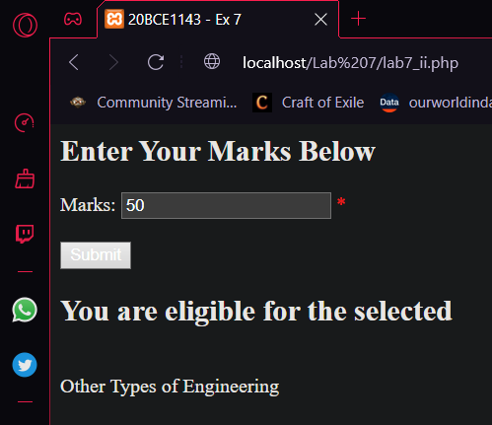

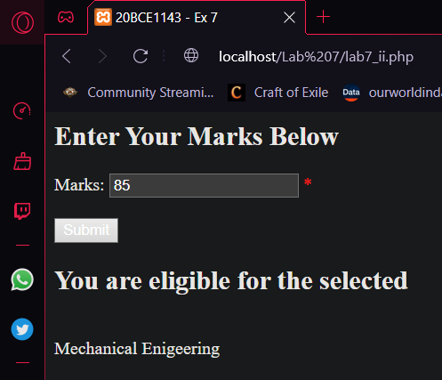



Code ->

<html>
<head>
<title>20BCE1143 - Ex 7</title>
<style>
.error
{
color:red;
}
</style>
</head>
<body>
<?php
$marksErr = "";
$marks = 0;
$validation = 1;
if($_SERVER["REQUEST_METHOD"] == "POST")
{
if (empty($_POST["marks"]))
{
$marksErr = "Required to Enter Marks";
}
else
{
$marks = test_input($_POST["marks"]);
$valid_marks = "/^[0-9]{1,2}$/";
$perfect_marks = "/100/";
if(preg_match($perfect_marks, $marks))
{
$marksErr = "Congrats on Perfect marks!";
}
else if(!preg_match($valid_marks, $marks))
{
$marksErr = "Enter Valid Marks";
$validation = 0;
}

}
}

function test_input($data) {
$data = trim($data);
$data = stripslashes($data);
$data = htmlspecialchars($data);
return $data;
}
?>
<h2>Enter Your Marks Below</h2>
<form method="post" action="<?php echo htmlspecialchars($_SERVER["PHP_SELF"]);?>">
Marks: <input type="text" name="marks" value="<?php echo $marks;?>">
<span class="error">* <?php echo $marksErr;?></span>
<br><br>
<input type="submit" name="submit" value="Submit">
</form>

<?php
echo "<h2>You are eligible for the selected</h2><br>";
if($validation==0)
echo "Invlaid Marks<br>";
else if($marks>=90)
echo "Computer Science and Engineering<br>";
else if($marks>=80)
echo "Mechanical Enigeering<br>";
else if($marks>=70)
echo "Civil Engineering<br>";
else
echo "Other Types of Engineering<br>";
?>
</body>
</html>

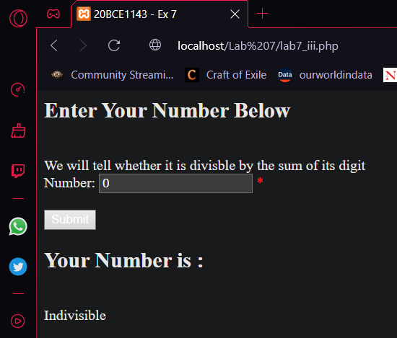

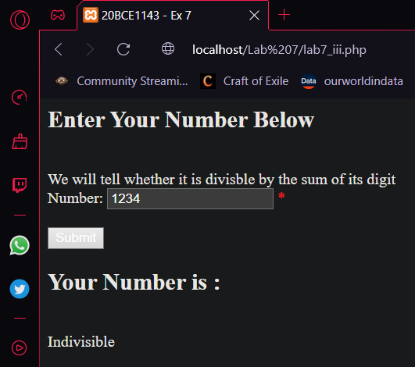

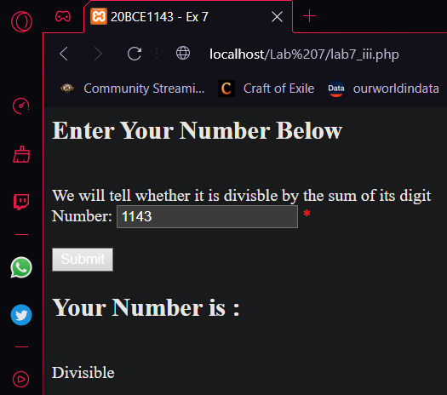

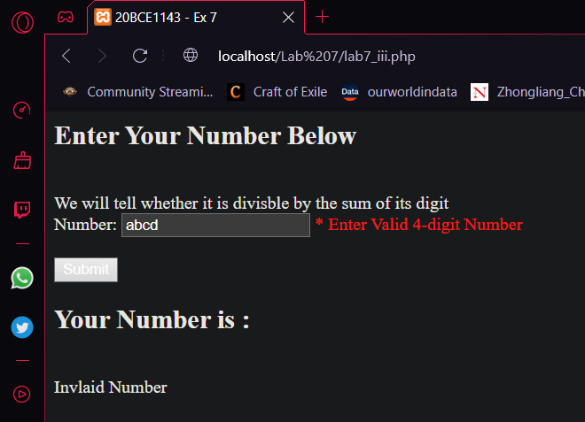

Code ->
<html>
<head>
<title>20BCE1143 - Ex 7</title>
<style>
.error
{
color:red;
}
</style>
</head>
<body>
<?php
$validation = 1;
$numberErr = "";
$number = 0;
$save = 0;
$sum = 0;
if($_SERVER["REQUEST_METHOD"] == "POST")
{
if (empty($_POST["number"]))
{
$numberErr = "Required to Enter Marks";
$save = $number;
}
else
{
$number = test_input($_POST["number"]);
$valid_number = "/^\d{4}$/";
if(!preg_match($valid_number, $number))
{
$numberErr = "Enter Valid 4-digit Number";
$validation = 0;
}
if($validation == 1)
{
$save = $number;
$i=0;
do
{
$sum = $sum + $number%10;
$number = ($number-$number%10)/10;
$i++;
}
while($i<4);
if(($save%$sum)==0)
{
$validation = 2;
}

}
}
}

function test_input($data) {
$data = trim($data);
$data = stripslashes($data);
$data = htmlspecialchars($data);
return $data;
}
?>

<h2>Enter Your Number Below</h2><br>
We will tell whether it is divisble by the sum of its digit<br>
<form method="post" action="<?php echo htmlspecialchars($_SERVER["PHP_SELF"]);?>">
<!-- we can also use HTML Pattern attribute for form -->
Number: <input type="text" name="number" value="<?php echo $save;?>" title="Four digit number">
<span class="error">* <?php echo $numberErr;?></span>
<br><br>
<input type="submit" name="submit" value="Submit">
</form>

<?php
echo "<h2>Your Number is : </h2><br>";
if($validation==0)
echo "Invlaid Number<br>";
else if($validation==1)
echo "Indivisible<br>";
else
echo "Divisible<br>";
?>
</body>
</html>

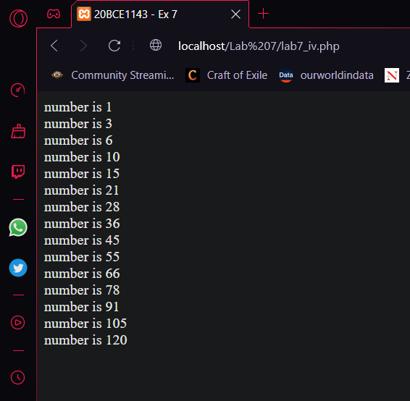

Code ->
<html>
<head>
<title>20BCE1143 - Ex 7</title>
</head>
<body>
<?php
$myArr = array(1);
$i=0;
do
{
$myArr[$i+1]=$myArr[$i]+$i+1+1;
echo "number is ".$myArr[$i]."<br>";
$i++;
}
while($i<15);
?>
</body>
</html>

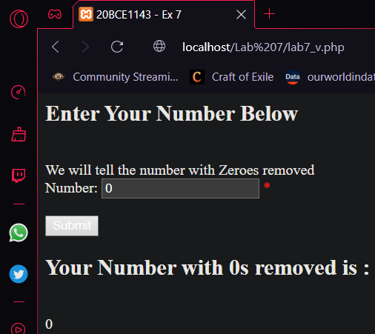

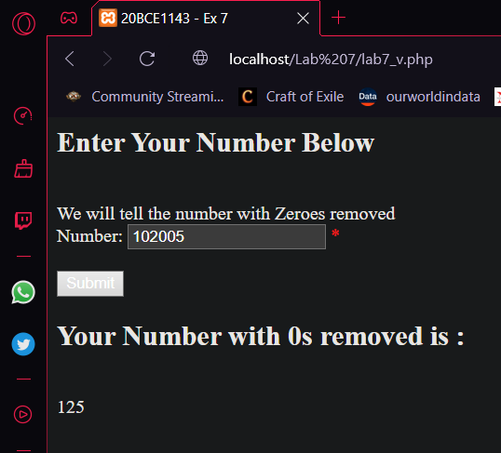

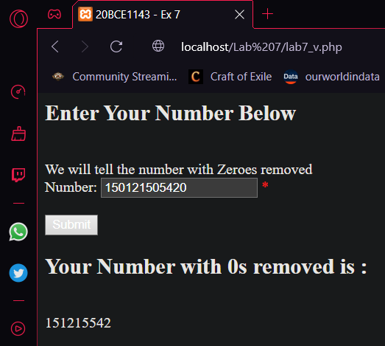

Code ->

<html>
<head>
<title>20BCE1143 - Ex 7</title>
<style>
.error
{
color:red;
}
</style>
</head>
<body>
<?php
$validation = 1;
$numberErr = "";
$number = 0;
$save = 0;
$og = 0;
if($_SERVER["REQUEST_METHOD"] == "POST")
{
if (empty($_POST["number"]))
{
$numberErr = "Required to Enter Marks";
$og = $number;
}
else
{
$number = test_input($_POST["number"]);
$valid_number = "/^\d*$/";
if(!preg_match($valid_number, $number))
{
$numberErr = "Enter Valid Number";
$validation = 0;
$og=$number;
}
if($validation == 1)
{
$og=$number;
$cur_size=1;
do
{
$whether_zero = $number%10;
$addendum=0;
if($whether_zero!=0)
{
$tenpow = pow(10,$cur_size);
$addendum = ($number%10)*$tenpow;
$save = $save + $addendum;
$number = ($number-$number%10)/10;
$cur_size++;
}
else
{
$number = ($number-$number%10)/10;
}
}
while($number!=0);
$save=$save/10;
}
}
}

function test_input($data) {
$data = trim($data);
$data = stripslashes($data);
$data = htmlspecialchars($data);
return $data;
}
?>

<h2>Enter Your Number Below</h2><br>
We will tell the number with Zeroes removed<br>
<form method="post" action="<?php echo htmlspecialchars($_SERVER["PHP_SELF"]);?>">
<!-- we can also use HTML Pattern attribute for form -->
Number: <input type="text" name="number" value="<?php echo $og;?>" title="Any digit number">
<span class="error">* <?php echo $numberErr;?></span>
<br><br>
<input type="submit" name="submit" value="Submit">
</form>

<?php
echo "<h2>Your Number with 0s removed is : </h2><br>";
if($validation==0)
echo "Invlaid Number<br>";
else if($validation==1)
echo "$save<br>";
else
echo "$save<br>";
?>
</body>
</html>

